Personal Development
Parson Street Primary School

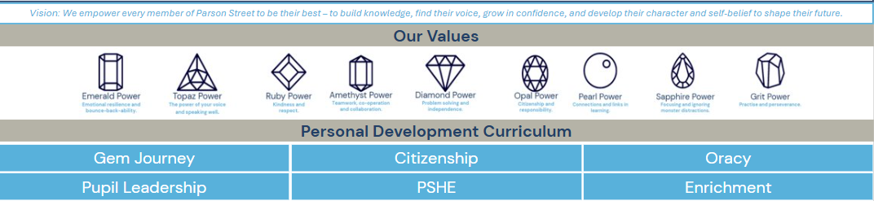
Intent
Vision
Our Personal Development curriculum at Parson Street brings our school vision to life by ensuring every child is supported to be their very best. Through rich experiences and purposeful opportunities, we ensure pupils develop knowledge, find their voice, grow in confidence and build the character and self-belief needed to shape their future.
Aims
Knowledge and understanding – Our knowledge-rich PSHE and Citizenship curriculums ensure pupils develop the knowledge, vocabulary and understanding needed to participate fully and successfully in modern society. The curriculum is ambitious, inclusive and designed to stretch and challenge all learners.
Cultural understanding and empathy – Through carefully planned curriculum experiences, pupils develop an awareness of different perspectives, cultures and lived experiences. Children are taught to be compassionate, respectful and thoughtful members of their community and the wider world.
Finding a voice – Our Citizenship curriculum, alongside our strong focus on Oracy, empowers pupils to ask questions, express opinions confidently, challenge respectfully and communicate effectively in an ever-changing world.
Growing in confidence – Pupils develop confidence through a wide range of leadership and enrichment opportunities, including roles such as School Councillors, Librarians, Green Team and OPAL Ambassadors, alongside sporting events, performances, competitions and creative projects.
Developing character and self-belief – The breadth of opportunities available to pupils helps them discover talents, develop resilience and build belief in their own potential across academic, creative, sporting and musical fields.
Inclusion and belonging – We are committed to ensuring that every child can access and benefit from personal development opportunities. Through adaptive practice, SEND support and proactive barrier removal, we ensure all pupils feel valued, included and successful.

Implementation
Our Personal Development strategy encompasses:
1. our 'successful learners' strategy, including learning gems and the gem journey
2. curriculum content we teach (through PSHE, citizenship & oracy)
3. enrichment we provide mapped against the DfE enrichment benchmarks to build belonging, skills and opportunities

- Successful Learners, Learning Gems and our Gem Journey
At Parson Street, we believe that learning how to learn is just as important as what is learned. Our Successful Learners strategy is a whole-school, metacognitive approach that explicitly teaches behaviour for learning. Through this, children develop a deep understanding of the attitudes, habits and strategies that lead to success—not only in the classroom, but in life. Central to this approach is a shared language around learning behaviours, which is used consistently across the school to help pupils reflect on how they learn, not just what they learn.​
You can read more about our learning gems here: Learning gems & behaviour
The Gem Journey is a carefully planned collection of experiences, opportunities and achievements that children work towards throughout their time at Parson Street. Every child receives their own Gem Journey book when they join the school, allowing them to celebrate and reflect upon the wider experiences that shape them as individuals beyond the academic curriculum.
The journey includes opportunities linked to leadership, creativity, culture, sport, community, resilience and personal growth, ensuring children leave Parson Street with a rich set of memories, experiences and accomplishments. Achievements are revisited and celebrated regularly throughout the year, culminating in a special celebration assembly with families. In Year 6, pupils take their completed Gem Journey home as a lasting keepsake of their growth, successes and experiences during their time at Parson Street. 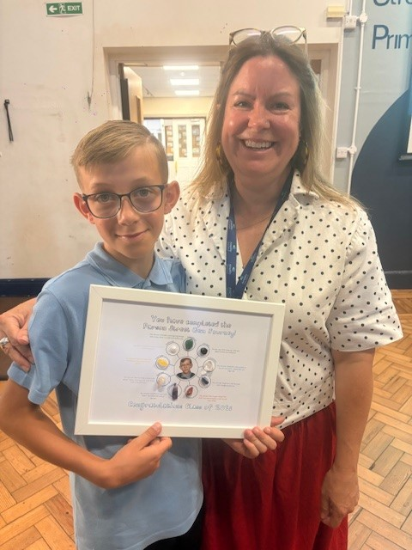 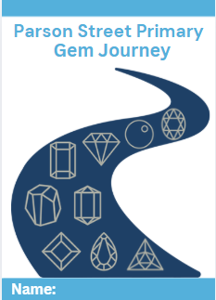 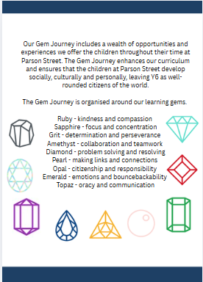 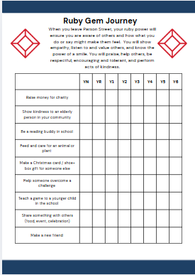

- Our Personal Development Curriculum
Citizenship Curriculum
At Parson Street, we believe citizenship should be a carefully designed, knowledge-rich curriculum that prepares children to participate thoughtfully, responsibly and courageously in modern Britain and the wider world.

Our approach recognises that children are not simply future citizens, they are citizens now. From Reception onwards, pupils are taught how communities function, how rights are protected, how laws shape society, and how individuals and groups can contribute positively to the world around them. They learn not only to belong to a community, but also how to participate in it with confidence, respect and integrity.

Citizenship education at Parson Street is delivered through two complementary elements of our wider Personal Development curriculum:

- Jigsaw PSHE
- Voices for Change (our bespoke, school-designed Citizenship curriculum)

Together, these provide a comprehensive and ambitious approach to developing pupils’ civic understanding, moral awareness and confidence to use their voice responsibly.

Voices for Change
Structure
Six key strands:

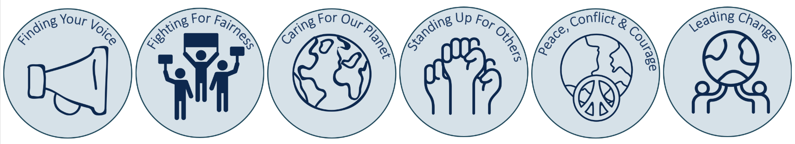

Term | Strand | Big Question
Autumn 1 | Finding Your Voice | When should we speak up?
Autumn 2 | Fighting for Fairness | How do people change unfair systems?
Spring 1 | Caring for Our Planet | Who protects the Earth?
Spring 2 | Standing Up for Others | How can we help people in need?
Summer 1 | Peace, Conflict & Courage | How do people choose peace?
Summer 2 | Leading Change | How do movements start?

Change Champions

Strand | Reception | Year 1 | Year 2 | Year 3 | Year 4 | Year 5 | Year 6
Finding Your Voice | Ruby Bridges | Rosa Parks | Greta Thunberg | Martin Luther King Jr | Nelson Mandela | Malala Yousafzai | Harvey Milk
Fighting for Fairness | Mary Seacole | Paul Stephenson | Emmeline Pankhurst | Claudette Colvin | Frederick Douglass | Ruth Bader Ginsburg | Nelson Mandela
Caring for Our Planet | David Attenborough | Jane Goodall | Chris Packham | Wangari Maathai | Greta Thunberg | Rachel Carson | Mya-Rose Craig
Standing Up for Others | Marcus Rashford | Mother Teresa | Irena Sendler | Florence Nightingale | Mary Seacole | Abdul Sattar Edhi | Desmond Tutu
Peace, Conflict & Courage | Wangari Maathai | Nicholas Winton | Malala Yousafzai | Martin Luther King Jr | Mahatma Gandhi | Desmond Tutu | Kofi Annan
Leading Change | Greta Thunberg | Marcus Rashford | David Attenborough | William Wilberforce | Harriet Tubman | Frederick Douglass | Wangari Maathai

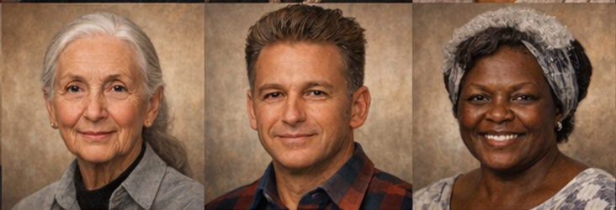
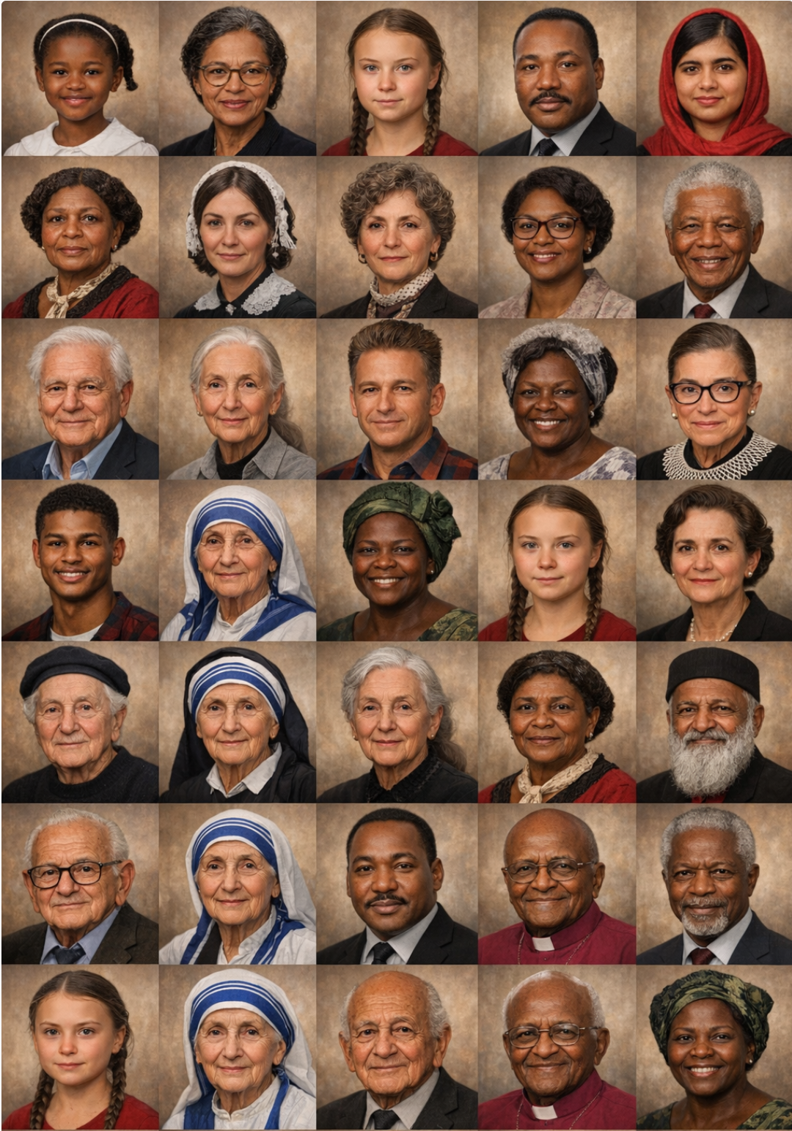
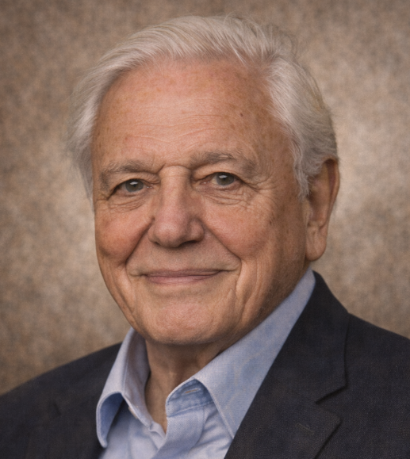
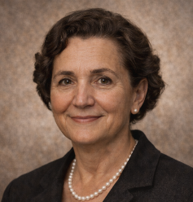
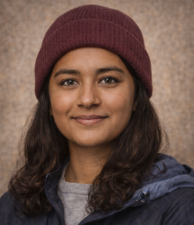
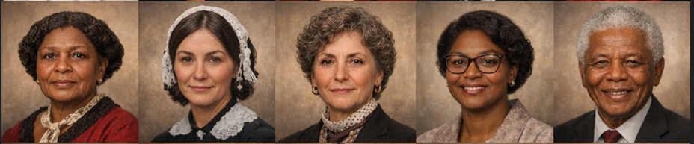
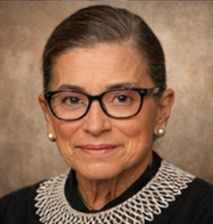
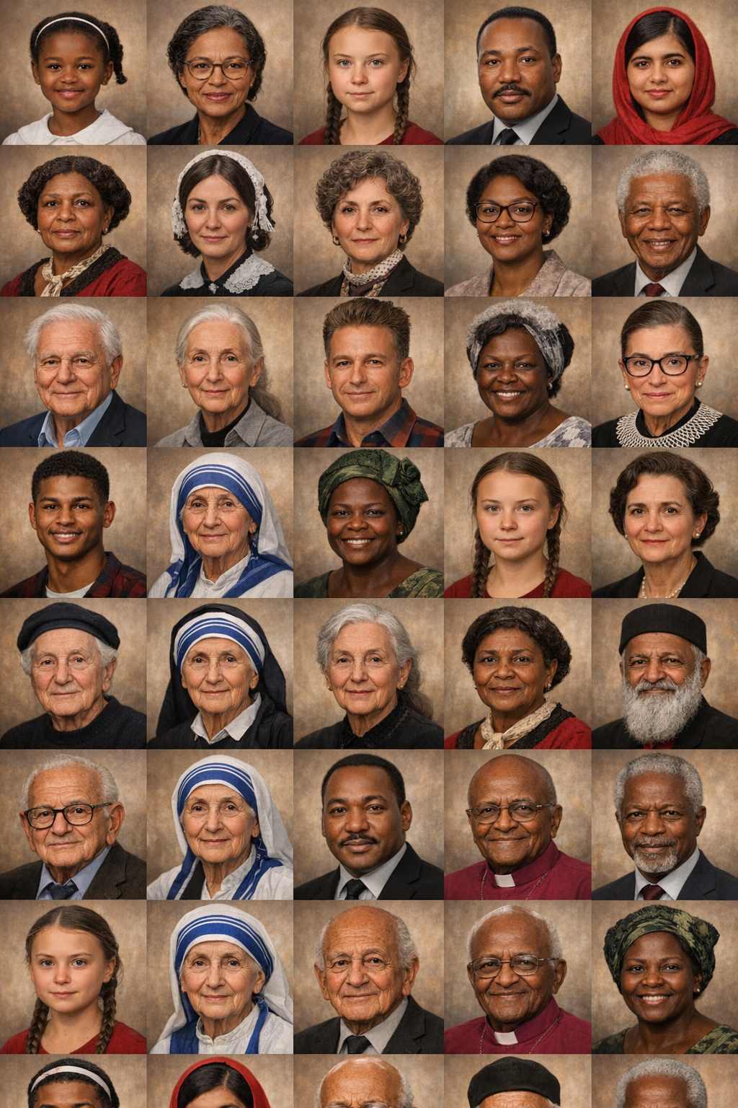
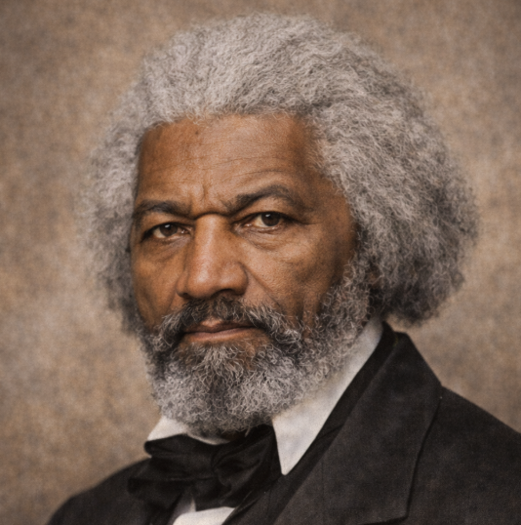
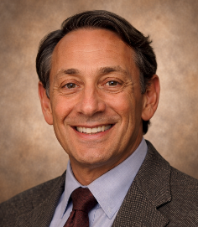

PSHE curriculum
The Jigsaw PSHE curriculum forms a core part of our Citizenship provision, and the children’s Personal Development. Through its structured programme of study, pupils develop the foundational personal and social understanding that underpins effective citizenship.

Jigsaw primarily addresses the personal and relational aspects of citizenship, including:

- understanding rules and why they exist
- recognising rights and responsibilities
- developing empathy and mutual respect
- understanding diversity and celebrating difference
- learning how communities function
- recognising the importance of fairness and inclusion
- developing emotional literacy and ethical awareness
- understanding how personal choices affect others

Through Jigsaw, pupils explore key ideas such as democracy, respect, tolerance and individual liberty within the context of classroom and school life. Pupils regularly engage in discussion, reflection and collaborative problem-solving, learning how to listen to others, articulate their own views and consider different perspectives.

In doing so, Jigsaw supports the promotion of Fundamental British Values, particularly:

- democracy (through discussion, shared decision-making and pupil voice)
- the rule of law (through understanding rules, responsibilities and fairness)
- individual liberty (through expressing views and making informed choices)
- mutual respect and tolerance of different faiths and beliefs

This work ensures pupils develop the personal, ethical and social foundations of responsible citizenship.

Oracy curriculum
At Parson Street, oracy is at the heart of our curriculum and underpins the way pupils learn, lead and contribute to the wider school community. We believe that every child should be equipped with the confidence, vocabulary and communication skills needed to express themselves clearly, articulate their thinking and engage respectfully with others.

Oracy is explicitly taught across the curriculum through discussion, debate, partner talk, presentation opportunities and high-quality questioning, with staff modelling ambitious language and sentence structures throughout lessons. Our Citizenship Curriculum further strengthens this by providing meaningful opportunities for pupils to develop leadership, advocacy and social responsibility. Through roles such as Opal Ambassadors, School Council, Librarians and classroom leadership opportunities, pupils learn how to communicate effectively, listen actively, challenge respectfully and represent the views of others.

We aim to ensure that all children leave Parson Street not only as successful learners, but as confident, articulate and socially responsible young people who understand the power of their voice.

- Opportunities for enrichment
The DfE Enrichment for All: benchmarks to build belonging, skills and opportunity report has identified 5 categories which indicate a range of activities which should be provided to school pupils.

1. Civic Engagement
At Parson Street, we believe that children should develop as active and responsible citizens who understand how they can make a positive difference within their school and wider community. Pupils are given meaningful opportunities to develop leadership through roles such as School Councillors, Opal Ambassadors, Green Team members and Anti-Bullying Ambassadors. Our bespoke Voices for Change Citizenship curriculum teaches children about democracy, social justice, equality and advocacy, while our School of Sanctuary work develops empathy, compassion and an understanding of migration and human rights. Community events, including our annual Family Food Festival, celebrate the diversity of our school and strengthen relationships between families and the wider community. This community event has represented over 16 nationalities and is a culmination of all the work we do around celebrating our differences and cultures. It demonstrates to children that we should be proud of who we are and our heritage, and to be curious and interested in others to better understand our world.
Parson Street is a diverse community in the South Bristol and we are proud to be a School of Sanctuary. This commitment reflects our belief that schools should be places of welcome, safety and belonging for children and families, regardless of background, language or life experience. Through our curriculum, assemblies and community events, pupils are explicitly taught empathy and compassion, respect for human rights, understanding of migration and displacement, inclusion and social responsibility.
Our whole school Personal Development planning overview ensures that the whole school covers significant events in the international and local calendars, including Black History Month, Refugee Week, World Book Day, Mental Health Day, Safer Internet Day, Anti-bullying Week and Remembrance Day. This planning also includes an assembly overview which also covers:
- Key events e.g. Black History Month
- Religious observances from World Religions and those of our community
- Gem learning powers
- Oracy skills focus e.g. talk partners
- Celebration and successful learners assemblies
- Safeguarding assemblies e.g. NSPCC, Online safety
- Mental Health and wellbeing assemblies
- Weekly singing assemblies
Our assemblies also include:
- Daily moments of reflection
- Good Morning using Makaton in English and then said in another language, using other children from the school who speak this if possible
- A focus on Equality, Diversity and Protected Characteristics
- A focus on British Values
Throughout the year, these assemblies, pupil voice opportunities and British Values education encourage children to participate confidently, express their views respectfully and understand the importance of contributing positively to society.
In summary, civic engagement at Parson Street includes:
- Pupil leadership through School Council, OPAL Ambassadors & Green Team
- Anti-Bullying Ambassadors
- Voices for Change curriculum
- School of Sanctuary
- Community Family Food Festival
- charity events e.g. Children In Need
- community partnerships e.g. Fair Trade link with Bristol council

2. Arts and Culture
We provide a rich programme of artistic and cultural experiences that broadens pupils' horizons and nurtures creativity. Our carefully planned Reading Spine for each class in the school deliberately exposes children to a diverse range of authors, cultures and perspectives. The books are carefully selected to ensure Representation, Equality, Diversity, Inclusion, Belonging and Mattering. Curriculum visits, performances and visits to deepen children's understanding of history, geography, art, music and science while bringing learning to life.
Our trips and visits support the children’s curriculum learning and their personal development. Notably, we visit the places of worship for the world’s major religions during the children’s education at Parson Street. Our overview ensures this is carefully planned out. Whole-school events, including World Book Day, Black History Month and celebrations of significant religious and cultural festivals, help pupils develop an appreciation of the diverse cultures and traditions that shape modern Britain and the wider world. Through music, art, drama and creative opportunities, children are encouraged to express themselves confidently and appreciate the contributions of others.

In summary, arts & culture at Parson Street includes:
- Reading Spine
- School trip visits to theatres and galleries/museums
- School trips to places of worship
- music performances
- Creative after-school clubs including art & bracelet making
- World Book Day
- Family Food Festival
- cultural celebrations including celebrating languages in assemblies
- Black History Month

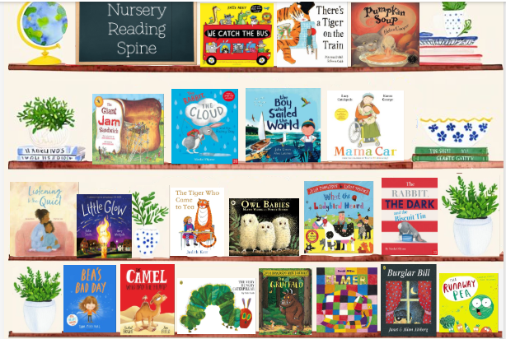
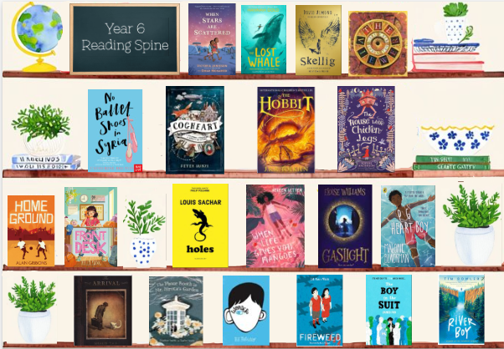

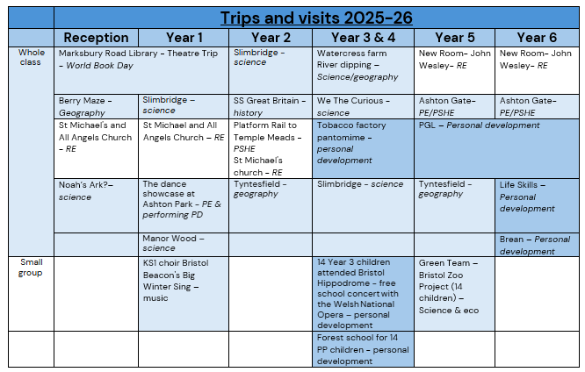

3. Nature, Outdoors and Adventure
Our enrichment programme provides regular opportunities for children to learn beyond the classroom and develop an appreciation of the natural world. Pupils participate in environmental initiatives through our Green Team, who work alongside staff to lead sustainability and climate projects across the school. Outdoor learning and active play are promoted in our school environment including the conservation area, EYFS meadow and well-resourced playground. These spaces encourage children to explore, collaborate and develop resilience through play. Residential visits and educational trips provide opportunities for pupils to develop independence, teamwork and confidence while experiencing new environments and challenges. Through these experiences, children develop a sense of responsibility for their environment and understand the importance of protecting the world around them.
In summary, nature, outdoors & adventure at Parson Street includes:
Include:
- Green Team
- gardening club
- Outdoor play including meadow and conservation area
- environmental projects
- residential visits
- climate learning

4. Sport and Physical Activity
We are committed to ensuring every child enjoys a wide range of physical activities and develops positive attitudes towards lifelong health and wellbeing. Pupils participate in a broad programme of sporting competitions, meets and inclusive events throughout the year, including opportunities specifically designed for children with SEND (Try-Golf and non-swimmer gala). Our after-school clubs are shaped by pupil voice and provide opportunities to participate in activities such as football, running and other physical pursuits, alongside a range of wider interests. Participation is carefully monitored to ensure all children, including those eligible for Pupil Premium, can access these opportunities. Through competitive sport, teamwork and active play, pupils develop resilience, confidence, cooperation and an enjoyment of being physically active.
In summary, sports & physical activity at Parson Street includes:
- PE competitions
- Sports Day
- swimming
- inclusive SEND sport
- after-school sports clubs including girls' football
- active play e.g. meadow

5. Wider Life and Future Skills
We prepare children for their future by developing the knowledge, skills and aspirations they will need beyond primary school. Our Future Me Fayre and Future Me Day introduce pupils to a diverse range of careers and encourage them to think ambitiously about their futures and engage in conversations with a range of professionals. A broad range of enrichment clubs, including computing, chess, Lego, art and other creative opportunities, develop problem-solving, digital literacy, collaboration and critical thinking skills. Throughout the curriculum, pupils develop oracy, leadership and communication skills that enable them to articulate their ideas with confidence and engage positively with others. Together, these experiences help children become resilient, adaptable and aspirational learners who are well prepared for the next stage of their education and beyond.
In summary, wider life & future skills at Parson Street includes:
- Future Me Fayre
- Future Me Day
- STEM clubs including computing, chess & lego
- digital literacy
- oracy
- Pupil leadership opportunities

Our Gem Journey acts as the vehicle through which all pupils access and record their enrichment experiences. Throughout their time at Parson Street, children work towards a carefully planned balance of opportunities across the five core enrichment categories (and linked with our learning gems), ensuring every pupil develops as an active citizen, creative thinker, confident participant, healthy individual and prepared learner.

How do we measure the impact of our Personal Development?
The impact of our Personal Development offer is seen not only in data, but in the confidence, character, belonging and aspirations demonstrated by our children every day.
Our whole-school wellbeing tracker is updated termly by class teachers, enabling leaders to identify emerging needs early, provide targeted support and carefully monitor the impact of interventions over time.
Pupil and parent voice are central to our evaluation process. Through the annual Trust survey, parents consistently describe:
- “a calm and supportive leadership that fosters trust and engagement”
- “a caring and inclusive school where children are known, valued and supported as individuals”
- “a school that celebrates diversity and belonging through meaningful community events”
- “a school focused on developing the skills needed for successful learning”
- “a staff team dedicated to supporting children and families”
We also participate in the annual Bristol Pupil Voice survey to deepen our understanding of the children and families we serve and to ensure our provision remains responsive to our community.
The impact of our work is perhaps most visible in the children themselves. Our Year 6 pupils, particularly those who take on leadership roles such as OPAL Ambassadors, leave Parson Street as articulate, compassionate and confident young people who are proud of who they are and excited for their future.
The rapidly growing number of families actively choosing Parson Street reflects the trust our community places in the school and the strength of the wider experience we provide for our children and families.

